|  |  |  |
| --- | --- | --- |
|  |  |  |
| E-01930-01-03RS01 |  | 31-May-2020 |
| **InMech Solutions** | | |
| **Smart Door Frame Profile Automation Tool** | | |
| Technical Specification | | |
|  | | |
|  | | |
|  |  |  |
|  | 1.0 |  |
|  |  |  |
|  |  | EMB_RM_01F /7.0/1-Apr-2020 |
|  |  |  |

DOCUMENT HISTORY

| **Ver. No** | **Release Date** | **Created. By**  **Creation. Dt** | **Rev. By**  **Rev. Dt.** | **Remarks/ Revision details** |
| --- | --- | --- | --- | --- |
| 1.0 | 31-May-2020 | Vijay Jadhav |  | Initial Release. |
|  |  |  |  |  |
|  |  |  |  |  |

**Table of contents**

1.0 Introduction 3

1.1 Purpose of this project 3

1.2 Key success Factors 3

1.3 Stakeholders Reference 3

2.0 Project Description 4

2.1 Overview 4

2.2 Scope of the Project for 2-Wheeler Green Tyre Profile Automation Tool 4

2.3 Parameter Calculations for 2-Wheeler Green Tyre Profile Automation Tool 12

2.4 Proposed NX Custom User Interface for 2-Wheeler Green Tyre Profile Automation Tool 12

2.5 Exclusions 15

2.6 Product Functions / General Descriptions 15

2.7 System Environment 15

2.8 Assumptions/Prerequisites for 2-Wheeler Green Tyre Profile Automation Tool 15

3.0 Application Environment 15

4.0 Strategy for requirements gathering 15

5.0 Non-Technical Requirements 15

5.1.1 Deliverables and Acceptance Criteria for NX 2-Wheeler Green Tyre Tread Profile Automation Tool 15

6.0 Deliverables Package 16

7.0 Glossary 16

# Introduction

## Purpose of this project

Below mentioned points serve as the Purpose of NX 2-Wheeler Green Tyre Profile Automation Tool:

1. Develop an NX Automation Tool with custom user interface (UI) to read and fetch the Parameters - “Gauge Cured Cap”, “Gauge Cured Base”, “Pitch”, “Land”, “Step” from Drawing (.dwg) that has been imported into NX.
2. To perform calculations based on the formulae and generate an Excel Document containing the below mentioned parameters in the form of Excel Columns:
   * Gauge Cured Cap
   * NSD Factor
   * Pitch
   * Land
   * %Land
   * Gauge Cured Land
   * Step
   * S Dia
   * Lift Ratio 2
   * Ø
   * sin Ø
   * Green Width
   * Green Tread Thickness cap
   * Gauge Cured Base
   * Green Tread Thickness base
   * X Coordinate
   * Green Tread Gauge (Y Coordinate)
   * Green ply angle α
3. To generate the 2-Wheeler Green Tyre Profile in the same work part with a new Drawing Sheet along with division Dimensions as explained in scope section.
4. To Calculate the Area, Volume for generated 2-Wheeler Green Tyre Profile.

## Key success Factors

Key success factors for this project are as follows:

* User does not have to manually calculate each and every parameter from the Drawing imported in NX.
* Automation tool will generate the Excel Document through Calculations for 2-Wheeler Green Tyre Profile Automation tool.
* The calculations done through automation will not involve any human intervention and the results will be error free.
* User does not have to manually generate the 2-Wheeler Green Tyre Profile & Mark the dimensions. This will be automatically done by the NX 2-Wheeler Green Tyre Profile Automation tool which in turn saves a lot of time.

## Stakeholders Reference

|  |  |  |
| --- | --- | --- |
| Project Coordinator (IMS) | Vijay Jadhav | Vijaay.jadhav@outlook.com |
| Team Members (IMS) |  |  |

# Project Description

## Overview

This Technical Specification Document is for “NX 2-Wheeler Green Tyre Profile Automation tool”. Following activities are involved in this tool:

* **Requirement Gathering and Analysis**
  + Requirements capturing through Web based/Skype meetings with Project coordinator from CEAT.
  + Technical Specification Document will be submitted to CEAT for approval.
* **Analysis & Implementation**
  + Development of application using NX Block Styler, C#.Net along with NXOpen Libraries.
* **Verification**
  + System testing at L&T offshore and **CEAT R&D IT environment** for 2-Wheeler Green Tyre Tread Profile Automation tool. **With at least 3 successful test case development**.

## Scope of the Project for 2-Wheeler Green Tyre Profile Automation Tool

As per our discussion and understanding, the scope/application steps are as mentioned below:

Step 1: User selects the Tread Bottom Profile spline in NX Block Styler UI Selection. The Tread Bottom Profile spline is as shown in below snap:

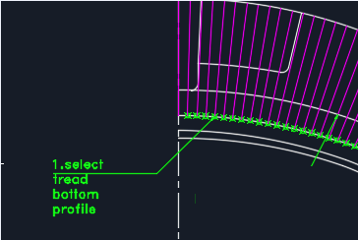

Step 2: User selects the NSD Profile spline in NX Block Styler UI Selection. The NSD Profile spline is as shown in below snap:

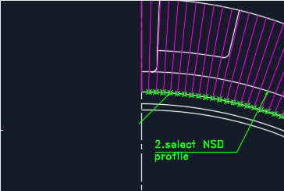

Step 3: User selects the Tread Top Profile spline in NX Block Styler UI Selection. The Tread Top Profile spline is as shown in below snap:

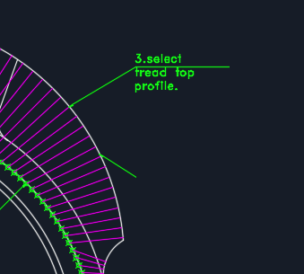

Step 4: User selects the Side Wall Outer Profile spline in NX Block Styler UI Selection. The Side Wall Outer Profile spline is as shown in below snap:

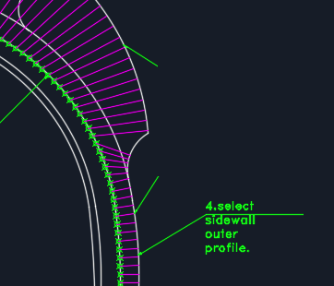

Step 5: Based on the Length of each division entered by user in the custom windows user interface field, the Tread Bottom Profile spline will be divided into divisions based on Length and will be marked using NX Point Set Feature. Kindly refer the below snap for an example:

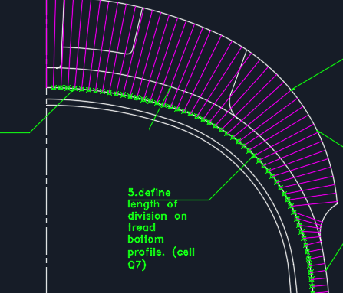

Step 6: From each created Division Point on Tread Bottom Profile Spline, follow the below steps:

* Create Perpendicular line (Normal Line) to Tread Top Profile Spline. This needs to be completed for entire Tread Top Profile Spline and should be stopped once Tread Top Profile Spline ends towards bottom side.
* Create Perpendicular line (Normal Line) to Side Wall Outer Profile Spline. This needs to be completed for entire Side Wall Outer Profile Spline and should be stopped once Side Wall Outer Profile Spline ends towards bottom side. This step will be carried out once perpendicular line creation on Tread Top Profile Spline is completed.
* Kindly refer the below snap for example:

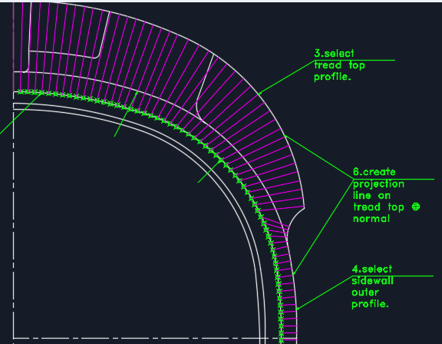

Step 7: Below mentioned parameters will be stored in the class structure in the code respectively:

* Length of each curve division (using the mathematical curve length formulae) present on Tread Top Profile Spline. The length of Tread Top Profile Spline will be equal to TDW Length.
* Measure the length of each Perpendicular line created at Normal to Tread Top Profile Spline and Sidewall Outer Profile Spline from each Division Point as shown in magenta color in above image.

After this step, the necessary activities on the bottom half of 2-Wheeler Profile Part will be completed. Now similar to Tread Profile Generation, the necessary Land and & %Land needs to be calculated for excel and profile generation as per the further steps.

Step 8: User will select the “TDW/2” line in NX Block Styler user interface. The validation for user selection will be that the “TDW/2” should be of Line type and not Spline. Below is the snap of “TDW/2” for user reference:

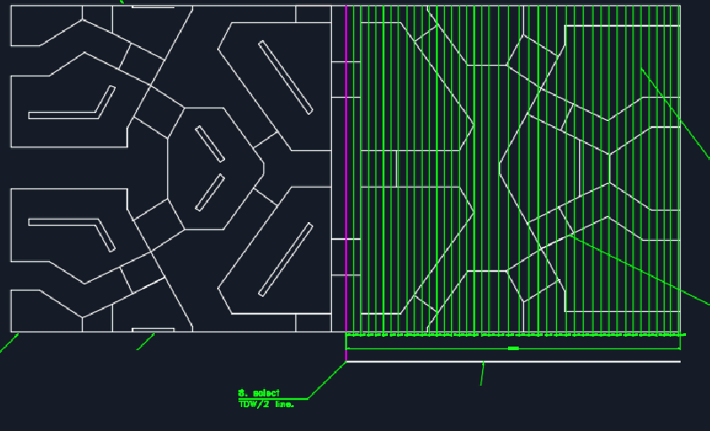

Step 8: User will select the Bottom Pitch line in NX Block Styler user interface. The validation for user selection will be that the Bottom Pitch Line should be of Line type and not Spline. Below is the snap of Bottom Pitch Line for user reference:

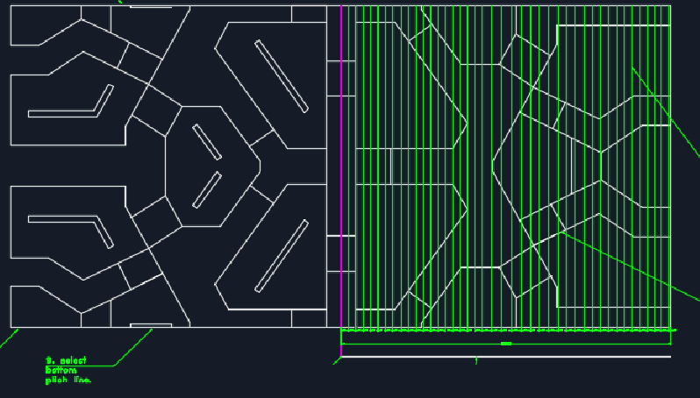

Step 9: User will select the Top Pitch line in NX Block Styler user interface. The validation for user selection will be that the Top Pitch Line should be of Line type and not Spline. Below is the snap of Top Pitch Line for user reference:

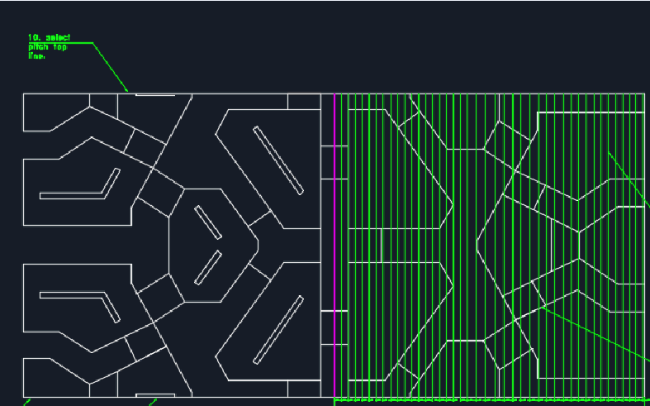

Step 10: Automation Tool will now fetch the “TDW/2” line selected by user and create divisions on the line with the help of NX OOTB Point Set/Point feature.

* The length between each division on “TDW/2” line should be same as that of respective curve length between divisions calculated from bottom half of 2-Wheeler Profile Part.
* The curve length between divisions should only be considered till the end of Tread Top Profile Spline.
* Based on the above mentioned statement, it is clear that the Length of “TDW/2” line is equal to the length of Tread Top Profile Spline.
* Kindly refer below snap for an example for “TDW/2” line divisions.

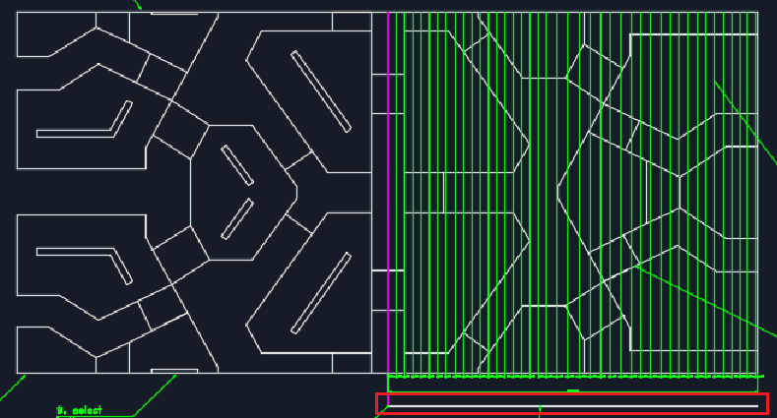

Step 11: Automation Tool will now Project the perpendicular lines from each division point present in “TDW/2” line till it intersects with Pitch Top Line.

* The Projection will be in “XY” direction and is a Pre-Requisite for the Automation Tool.
* This step will make the perpendicular line to intersect the individual Extrude Blocks created manually by user.
* Kindly refer below snap for an example for Projection Lines:

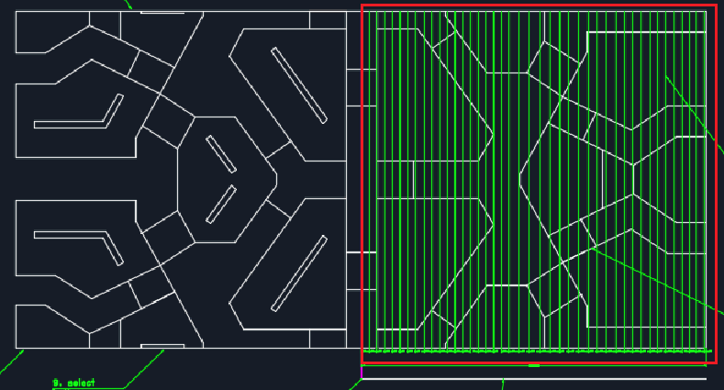

Step 12: Automation Tool will now internally calculate the “Land” & “%Land” Calculations similar to the functionality implemented in Tread Automation Tool. The Details regarding the calculations will be stored internally in the automation tool.

Step 13: Automation Tool will now proceed to calculate the “GAUGE CURED CAP” parameter from the bottom part of 2-Wheeler Profile Part. This will be filled in Column B of excel calculation document. This calculation involves 2 Steps:

* Measure Distance between NSD Profile Spline and Tread Top Profile Spline till Tread Top Profile Spline ends. The Length at each division should be filled respectively in **Column B** of excel calculation document.
* Measure Distance between Tread Bottom Profile Spline and Sidewall Outer Profile Spline till Sidewall Outer Profile Spline ends. The Length at each division should be filled respectively in **Column B** of excel calculation document.
* Measure Distance between NSD Profile Spline and Tread Bottom Profile Spline at each division. The measured Length at each division should be filled in **Column O** of excel calculation document.
* Kindly refer the below snap for an NX example:

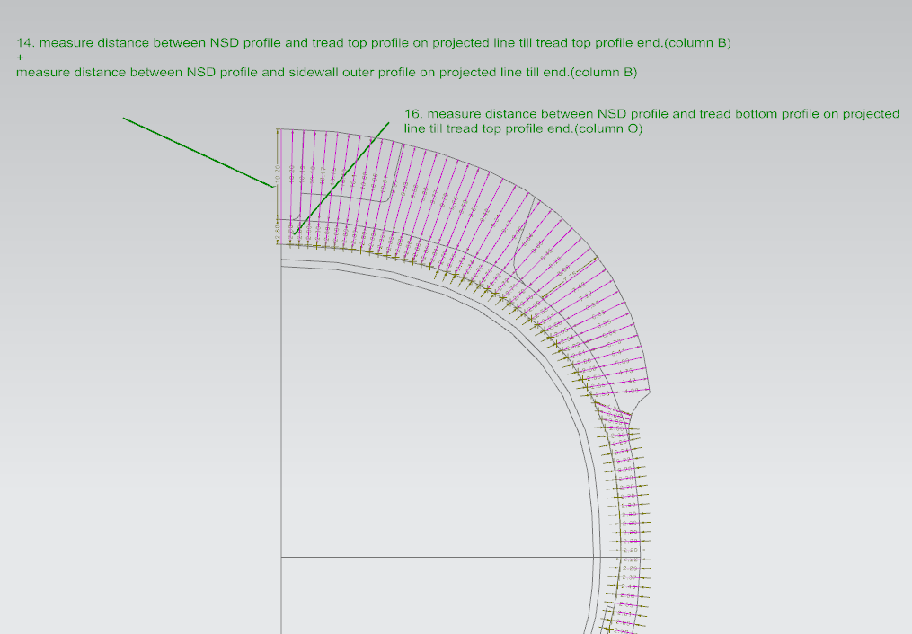

Step 14: For PITCH Calculation: Automation Tool will calculate the distance between the Pitch Top Line and the Pitch Bottom Line.

* The assumption here is that the Pitch Top Line and Pitch Bottom Line will always be Parallel.
* PITCH calculation will be filled in Column C of excel calculation document and will be filled only till Tread Top Profile Spline Divisions and will be blank for Sidewall Profile Spline Divisions.
* Kindly refer the Below snap for an example of calculation:

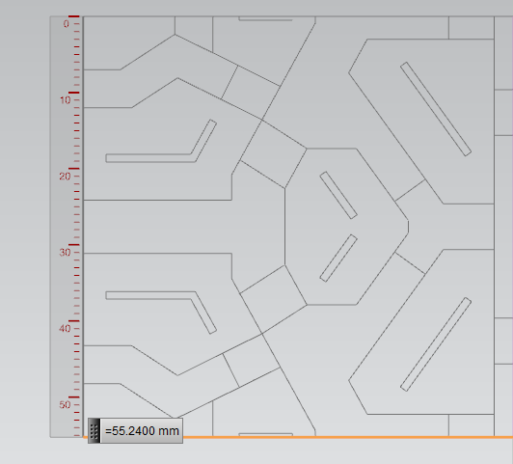

Step 15: For STEP Calculation, below procedure will be followed.

* In case the Division Points on Bottom Tread Profile Spline lies above the Drum Line, Automation Tool will calculate the distance between the individual Division Points marked on Bottom Tread Profile Spline and the Drum Line.
* In case the Division Points on Bottom Tread Profile Spline lies below the Drum Line, then for such divisions STEP value will be considered as 0.

Step 16: Excel Calculation Document Generation:

* Below shown snap from Excel will act as a template for Excel Calculation Document Generation. This will be basically from Row 1 to Row 10.
* Values highlighted in above snap will be updated based on User Inputs or based on calculations.
* Rest of the calculations from Column A to Column S after Row 10 will be as per the next mentioned points below.
* **Lift Ratio (1)** = Is a Formulae.
* **Mean Carcass Dia** = Is a Formulae.
* **Green ply angle α** = If Auto Calculation option is selected by user in custom user interface, then = Is a Formulae, else if Manual option is selected by user in custom user interface then value will be filled based on user input.
* **TRD Point** = Division Number from Tread Bottom Profile Spline.
* **Gauge Cured Cap** = Calculated from STEP – 13
* **Pitch** = Calculated from STEP - 14.
* **Land** = Calculated from STEP - 12.
* **%Land** = Is a Formulae.
* **Possion Ration** = Is a user input.
* **Gauge Cured * Land** = Is a Formulae.
* **Step** = Calculated from STEP - 15.
* **S Dia** = Is a Formulae.
* **Lift Ratio 2** = Is a Formulae.
* **ø** = Is a Formulae.
* **Sin ø** = Is a Formulae.
* **Green Width (Wg)** = Is a Formulae.
* **Green Tread Thickness cap (Tg1)** = Is a Formulae.
* **Gauge Cured Base** = Calculated from STEP - 13.
* **Green Tread Thickness base (Tg2)** = Is a Formulae.
* **(X cordinate)** = Is a Formulae.
* **Green Tread Gauge (Tg=Tg1+Tg2) (Y cordinate)** = Is a Formulae.
* **Remarks** = Will be a Blank Value.

Apart from the above mentioned calculations, below conditions needs to be kept in mind while generating the excel:

* %Land for Side Wall Outer Profile Spline Projected Divisions will always be 1.
* Pitch and Land Column Values will be merged for Side Wall and will have the value = SW.
* X Coordinate for First Division will always be 0. Rest will have the Formulas.

Step 17: Drawing 2-Wheeler Green Tyre Profile Generation:

* Create Horizontal Profile Base Line equal to the maximum length of X Corrdinate calculated in Excel Calculation Document. The Position of the 2-Wheeler Green Tyre Profile will be configurable and will be present in the configuration file.
* Divide the Horizontal Profile Base Line into Divisions based on the X Coordinate calculated in Excel Calculation Document.
* Create Vertical Lines by at each Division marked on Horizontal Profile Base Line. The length of the vertical line will be equal to the respective Y Coordinate calculated in Excel Calculation Document.
* Create Spline Curve passing through the top point of each vertical line generated in the previous step.
* Delete all the vertical lines generated on the Horizontal Profile Base Line. Now only the Horizontal Profile Line and Spline Curve will be retained.
* Now re-create divisions on Horizontal Profile Base Line. The distance between each division will be defined by user in custom user interface. The parameter name is “Drafting Segment”.
* Create Vertical Line on each division on Horizontal Profile Base Line. These Vertical Lines should intersect the Spline curve and will be trimmed at the intersection.
* Create a Major Horizontal Dimension i.e, Dimension of Horizontal Profile Base Line.
* Create Minor Horizontal Dimensions for distance between Divisions on Horizontal Profile Base Line. The Dimension should be in ascending order along with summation of Drafting Segment. For Example: If Drafting Segment = 3, then the Minor Horizontal Dimensions will be: 3,6,9,12….etc.
* Create Vertical Dimensions by measuring the length of each Vertical Lines generated at each division on Horizontal Profile Base line.
* A Drafting Note will be added in the Drawing Sheet with below mentioned parameters:
  + Size
  + Pattern
  + Plant
  + Layout Drawing No.
  + Area and Volume calculated.

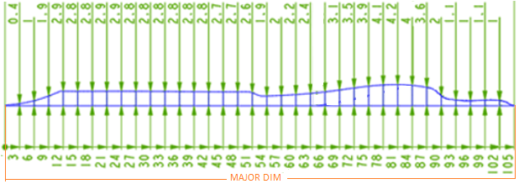

Note: The Profile drawn in above snap is just an example, the exact profile will vary from case to case.

## Parameter Calculations for 2-Wheeler Green Tyre Profile Automation Tool

* **Green ply angle α = (180/PI() *ACOS((1+O7)*COS(K5*(PI()/180))/O6))**
* **Mean Carcass Dia = M5-(2*H5+(2*((H6*K6)+(H7*K7))*0.9/2))**
* **Lift Ratio (1) = O5/M7**
* **% Land = D11/C11**
* **Gauge Cured * Land (Tc1) = B11*E11 (Gauge Cured Cap x % Land)**
* **S Dia = (Drum Dia(expanded)+2*step)**
* **Lift Ratio 2 = S Dia/ (Drum Dia (expanded)+2*Total Carcass Gauge)**
* **ø = ACOS (Lift Ratio 2 * cos α) / (1+e)**
* **Green Width (Wg) = (Wc * sin α) / {(sin ø) * (1+e)}**
* **Green Tread Thickness cap (Tg1) = Tc1 * Lift Ratio 2*(1+e)* {(sin ø * Spec. gravity cured)/(sin α* spec. gravity green)}**
* **Green Tread Thickness base (Tg2) = Tc2 * Lift Ratio 2*(1+e) * {(sin ø * Spec. gravity cured)/(sin α* spec. gravity green)}**
* **X coordinate = (X coordinate previous) + respective Green Width**
* **Green Tread Gauge (Tg=Tg1+Tg2) (Y coordinate) = Green Tread Thickness cap (Tg1) + Green Tread Thickness base (Tg2) respectively.**

## Proposed NX Custom User Interface for 2-Wheeler Green Tyre Profile Automation Tool

#### Custom NX User Interface for Profile Selection

#### Custom User Interface to define Parameters

#### Custom User Interface to Edit 2-Wheeler Profile Division Line Angles

#### Custom User Interface to Generate 2-Wheeler Profile & Save NX Part with Excel Document

## Exclusions

Following activities are excluded from the scope of this project:

* Generation of Profile Segment Divisions other than that of 2-Wheeler Green Tyre Profile as mentioned in Scope of Work.
* Migration of Drawing (.dwg) file into NX Session [NX OOTB import functionality].
* Creation of NX entities other than that of Points and Lines.
* Displaying Calculations other than that of Excel Format Calculations in Custom User Interface.
* Drawing Sheet (“A4” & “A3” Format) saved in NX Part having the Green Tyre Profile, will not be Exported to any other Format by Automation Tool. User has to manually perform this activity.
* Support for system other than Windows 7 64-bit & NX 10.0.

## Product Functions / General Descriptions

This project will facilitate Generation of Excel Document for NX 2-Wheeler Green Tyre Tread Profile Automation. The generated Excel Document will mention various Parameters listed in the form of Excel Columns.

## System Environment

* Tool will be developed using C# .NET & NXOpen Libraries.
* Tool will be tested in NX 10.0 and NX 11.0, Windows 7, 8, 10 64-bit (English US Regional Settings) environment.
* Number of Installations/Licenses for 2-Wheeler Green Tyre Tread Profile Automation Tool will be same as PCR Project.
* Improvements identified in PCR module will be implemented in 2-Wheeler Green Tyre Tread Profile Automation Tool and will be deployed accordingly.

## Assumptions/Prerequisites for 2-Wheeler Green Tyre Profile Automation Tool

Following assumptions are made for the execution of this project:

* Migration of Drawing (.dwg) file into NX Session Task will be performed by user manually.
* Division Point & Lines will be generated in 3D and will be used for calculation.
* Application, Excel Document and User Manual will be created using English language only.
* User must be inside CEAT User Domain to use the NX 2-Wheeler Green Tyre Tread Profile Automation Tool.
* Placing the 2-Wheeler Green Tyre Profile in drawing space will be configurable. User can specify the X, Y Coordinates in configuration file to place the profile.

# Application Environment

Tool will work and will be compatible with NX 10.0 & NX 11.0. The NXOpen API’s used for this project development may malfunction in later NX Versions. For this case, a new built with CR needs to be raised.

# Strategy for requirements gathering

* Requirements capturing through Web based/Skype meetings with on-site coordinator and CEAT.
* Online Skype meetings with CEAT to discuss queries if any.

# Non-Technical Requirements

### Deliverables and Acceptance Criteria for NX 2-Wheeler Green Tyre Tread Profile Automation Tool

CEAT will approve the Technical Document as per the timeframe mentioned in the below table. The Delivery Target for the tool has also been mentioned in the below table. In case no response is received from CEAT after delivery, the deliverables will be deemed as approved.

| **Sl. No** | **Deliverables** | **Approval/Delivery Date** | **Responsibility** | **Remarks** |
| --- | --- | --- | --- | --- |
| 1 | Technical Specification Doc. |  |  | - |
| 2 | Project Status Report (PSR) | Review and approval within 2 days from submission |  | - |
| 4 | Application Executables | To be updated |  | - |

# Deliverables Package

Deliverables Package will contain the below mentioned files:

1. NX2WheelerGreenTyreProfileTool.dll
2. NX Ribbon Configuration Files
3. NX Menu Bar Configuration Files

# Glossary

|  |  |
| --- | --- |
| **Abbreviation** | **Explanation** |
|  |  |
|  |  |